Contact: Mark A. Spawn  Director of Research, Development and Training  New York State Association of Chiefs of Police  2697 Hamburg Street, Schenectady, NY 12303  Phone 518-355-3371 Fax 518-356-5767 |  | New York State  Association of  Chiefs of Police, Inc.
Press Release

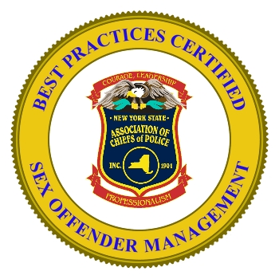
Canandaigua Police Recognized
for Sex Offender Management
Keeping Communities Safe Using Best Practices
SCHENECTADY, NEW YORK – November 6, 2009 The Canandaigua Police Department has been certified by the New York State Association of Chiefs of Police (Association) in a new sex offender management program. The certification recognizes that the Canandaigua Police are employing proactive and sound practices in managing sex offenders in their community. The “Certified Best Practices” program was launched in January to recognize police agencies that employ certain strategies to monitor sex offenders, provide community notification and conduct enforcement. Association Executive Director John P. Grebert said, “For more than a decade, managing sex offenders has become an important function of law enforcement. Police are on the front lines in ensuring that offenders comply with the law and that citizens are informed about certain offenders living in their communities.”

Association President William J. Kilfoil (Port Washington PD) said, “The New York State Association of Chiefs of Police is pleased to provide this service to our members. It is a nice acknowledgement for the hard work being done to monitor sex offenders throughout New York State.”

The policies and operations of the Canandaigua Police Department were assessed and found to be in compliance with the elements of the Best Practices program. In addition to having a written policy pertaining to sex offender management, they were also required to provide proof of monitoring of offenders, community notification, cooperation with other agencies, and enforcement.

The Association’s director of research, development and training, Mark Spawn noted that the Best Practices program takes several factors into consideration. “This program identifies the most important aspects of sex offender registration and gives agencies the ability to have an external validation of their processes.” Spawn extended a special thanks to Sgt. Rick Youngs who provided information and documentation to demonstrate the agency’s compliance for the certification program.

The Association’s program was presented at a National Symposium on Sex Offender Management in Houston in April. Spawn also said that for agencies that do not yet have a policy in place, the Association has resources to assist departments in developing a plan to meet their individual needs.

